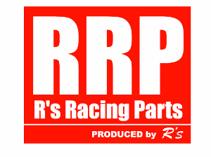
Order form of RRP Super ROM ECU for ZC32S
Dear Customers :
Please fill the information we need for each modification of RRP Super ROM ECU re-program to your Swift Sport ZC32S car as follow.
Your Name
Address
Country
Phone number
E-mail | @
Year of your car
Body number | ZC32S -
ECU number | -
Spec of your car  (please inform us the modification of your car) | Muffler :  Catalyst :  Air cleaner :  Throttle :  Other :  Temperature :  Gasoline octane rate :
Requirement if any

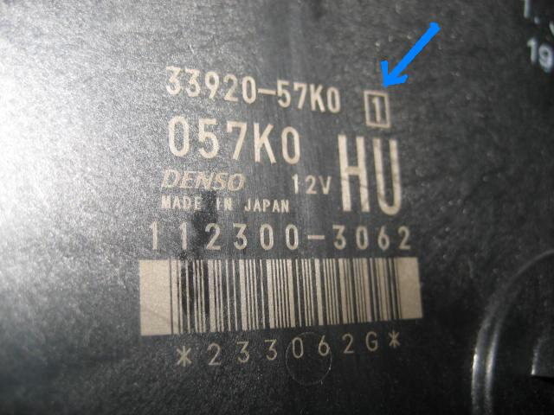
Please check your ECU number reference with the picture

All copyright (C) Reserved by R's inc Japan 2008 - 2013

